St. Jean Elementary School Newsletter
November 2021
Principal: Maureen Cassivi
Vice-Principal: Mark J. Kelly
Administrative Assistant: Dale MacInnis
Guidance Counselor: Louise Doucette School Web Page: https://stjeanelementary.edu.pe.ca/
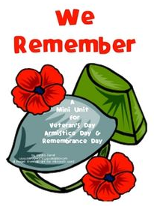
Happy November staff, students and teachers! It is hard to believe that we have been in school for two months already! Thanks for working in partnership with the school to support your child and their educational experience this school year! October was a busy month with lots of learning and we look forward to our upcoming parent-teacher interviews on the evening of November 25th & 26th. Interview dates will be going home soon, so please keep a look out for it.
Virtual Remembrance Day Celebration
Our students will be participating in a virtual Remembrance Day Celebration on Wednesday, November 10th. This will also be shared on our private school Facebook page on that day. A big thanks, Mrs. Ellis, for organizing this with our students.
Important Dates
November
3rd – Picture Re-take Day
10th – Remembrance Day Assembly
11th – Remembrance Day (no classes)
12th & 15th – Annual Convention (No Classes)
23rd – Term 1 Report Cards
25th – Parent-Teacher Conferences (After School)
26th – Parent-Teacher Interviews (No Classes)
December
7th – Christmas Concert (Storm Date: Dec. 8th)
9th – Holiday Shoppe
17th – Last Day of Classes 2021
20th - Professional Learning Day (No Classes)

We are really excited to share our living wall in the foyer. Students take turns looking after it, learning about gardening and watching the changes.

We have been hard at work with our Flexible Learning Centre (FLC). A big shout out to all who contributed financially to this project. With the funds received we have been able to purchase several items to make it a calming environment assisting in self-regulation for our students.

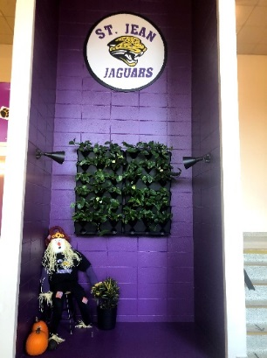
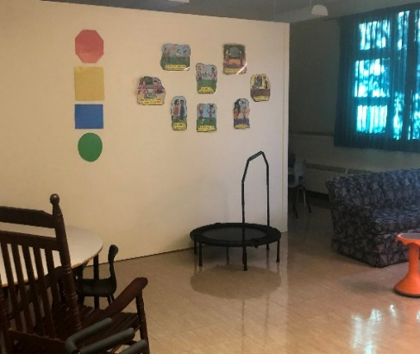
Now that the colder weather has approached us, we want to ensure all children are coming to school daily, with appropriate clothing. This includes a winter hat, gloves, snow boots, snow pants, and winter jacket to keep the children warm while playing outside.

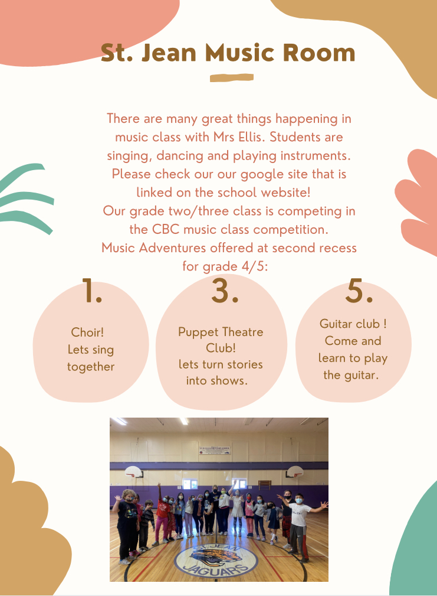
Parent Teacher Conferences: Conferences are being held Thursday, November 25th after school and Friday, November 26th in the morning. Forms went home on Thursday with students. Please review your scheduled time and return it to the school as soon as you can to either confirm your attendance or to arrange another time. If you didn’t receive a conference times please call the school.
Library News from Miss Barb

Alyre and Gavin have written their own graphic novel, The Battle of the Century, which they have donated to the library. This joins The Adventures of the Mysticals written by Grade 6 students last June. The library has also received some new books from Scholastic including a new Baby-Sitter Little Sister graphic novel.
Sydney and David, from the Grade 5-6 class, are being trained as library monitors to help sign out library books and to help students locate materials.
Library displays this month will celebrate Diwali (Nov 7th), Remembrance Day, Canadian History Month (November 20-26) and several author birthday's including L.M. Montgomery's on November 30th.
The travel club for Grades 4 to 6 meet Wednesday afternoons at second recess and will be taking imaginary trips to Rome, Belgium and the Ukraine this month.
Students in Grades 4 to 6 are reminded about the Hackmatack Children's Choice award. There is a display of the books on the shelf beside the first door. If they read 5 fiction and/ or 5 non-fiction books from the Hackmatack list they are entitled to vote for the winner.

Monthly Calendar: Every month we will send home a calendar of events at St. Jean Elementary. Please post it on your fridge or somewhere you will see it to stay in tune with our school news and dates.

HOME & SCHOOL NEWS -

November 3rd

Home and School News
The Provincial Semi-annual Home and School Meeting was held on October 21. There was a panel discussion that covered topics such as Reconciliation, PowerSchool and COVID updates, Social Media and Internet Safety, as well as Gender Identity and How to Address People. It was a very informative night.

Our St. Jean Home and School meets every two months and will meet again on Friday, December 3 at 1:30. New members are always welcome! Please join us to be a part of your child’s education.

St. Jean School Clothing

St. Jean Elementary School will be selling school clothing starting Monday, October 18th. This year, we have partnered with a local clothing company called Stay Golden Custom Clothing. School clothing will be sold online through the following website: https://stjeanelementary.staygolden.ca/

On the website you will find youth and adult sized items: cotton t-shirt ($20), dry fit t-shirt ($26), long sleeve shirt ($30), hoodie ($35) and a mask ($12.50). Prices include taxes. All items are available in black or purple except for the mask (black only).

The online website store is open until Monday, November 1st. Mastercard or Visa are the forms of payment accepted on the website store. If you do not have access to a credit card, please contact your child’s homeroom teacher or the school at (902) 368-6985 for an order form to pay with cash.

Clothing items that you purchase will be delivered to the school about 2-3 weeks after the website store closes.
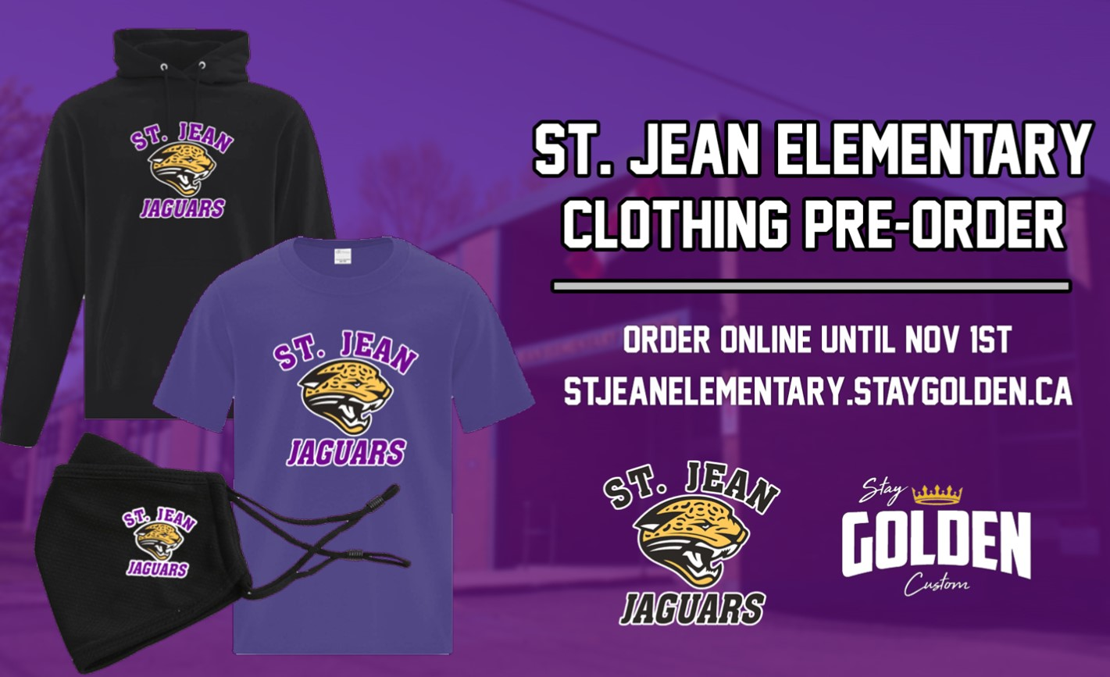

Cookbooks for sale: Last year students and staff participated in creating a multicultural cookbook. There are a few cookbooks remaining and can be purchased for $12.00 each. They would make a great stocking stuffer! Orders can be sent in to homeroom teachers.

Holiday Shoppe: Once again we will be having our Holiday Shoppe in early December. Students are asked to bring in slightly used items for others to purchase,
for example an ornament, decorations etc.
These items can be sent at any time and given to Mrs D.

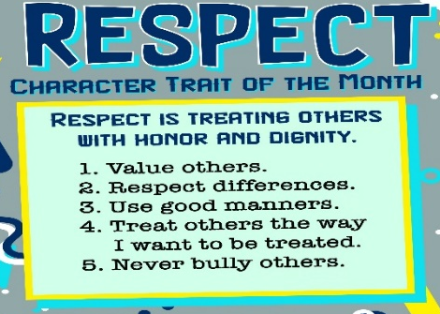
Congratulations to the Leadership Students who recently received their training. They have been active in assemblies and planning recess games for the 3-6 students at lunch. They look forward to many other helping roles in the school.

Counselor Corner: Each morning starts with the FOCUS Sequence to get students ready to learn. In November we are going to concentrate on our breathing and being mindful.

