St. Jean Elementary School Newsletter
March 2022
Principal: Maureen Cassivi
Vice-Principal: Mark J. Kelly
Administrative Assistant: Dale MacInnis School Web Page: https://stjeanelementary.wordpress.com/
Guidance Counselor: Louise Doucette
March
3rd-4th – Parent-Teacher Interviews
10th – Term 2 Report Cards
11th – PA Bingo
13th – Daylight Savings
14th-18th – March Break
20th – Spring Begins

April
15th -18th – Easter Weekend, no classes
1^{s t}– School Goals Day K-9, no classes

Parent-Teacher Conferences are this month – March 3th and 4th! We look forward to the chance to talk with you about your child’s progress. Here are a few tips to help you make the most of your conference time:
- Get ready. Jot down notes about what you want to share or ask about.
  - Any questions about the school’s programs or policies.
  - Things you can share with the teacher about your child and his/her life at home.
  - Questions about your child’s progress.
- Ask questions. Don’t be afraid to ask the teacher directly if there is a concern or something is unclear.
  - What are my child’s strengths and weaknesses?
  - How does my child get along with classmates?
  - Is my child working up to his/her ability? Where could he/she use improvement?
  - What can we do at home to support what you are doing in the classroom?

AFTER SCHOOL PICK UP/BUSSING - If you need to make a change to after school pick up or bussing, please contact the school no later than 1:00 p.m., so that we can guarantee that the information gets to you child’s teacher.
Honesty is our Character Trait for the month of March. SJ Jaguars show this trait by doing the right thing regardless of who is around and by doing what you say you will do.

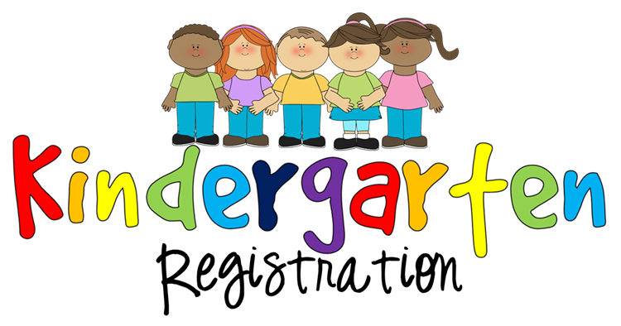
KINDERGARTEN REGISTRATION FOR SEPTEMBER 2022 ~ REMINDER!!: If you know someone in our school zone who has a child who will be 5 years old by December 31, 2022, please let them know that it is kindergarten registration time. We are in the process of looking at staffing for the upcoming school year, and to make sure we are adequately staffed for next year, we need to have our new kindergarten students registered. Please ask parents to drop by St. Jean Elementary School to fill out the registration form (child’s PEI Health Card and Birth Certificate, as well as, proof of home address e.g. utility bill, etc.).

March Break is Coming! We wish you and your family a safe and enjoyable March Break. The school is closed from Monday, March 14 to Friday, March 18. Also, don’t forget to set your clocks ahead 1 hour on Sunday, March 13, as Daylight Savings Time begins!
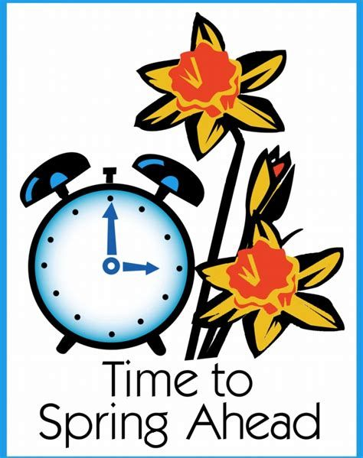
Clocks go forward on March 13th

