Monday | Tuesday |  | Wednesday | Thursday | Friday
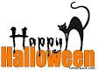

OCTOBER 2021

 |  | 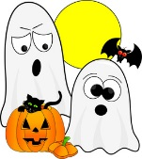 |  |  | 1  Joint Staff (No School)
4  Grilled Cheese & Veggies | 5  Quiznos Sub  Picture Day |  | 6  Quiznos Salad | 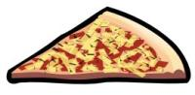  7  Cheese Pizza  Lunch Orders Due Noon | 8  Professional Learning Day  (No School)
11  Thanksgiving (No School) | 12  Quiznos Sub |  | 13  Cheese Pizza | 14  Chicken Poppers & Breadsticks & Carrots & Garlic Fingers | 15  Garlic Fingers  H&S Meeting 1:00 p.m.
18  Chicken Strips & Veggies | 19  Quiznos Sub |  | 20  Cheese Pizza | 21  Chicken Poppers & Breadsticks & Carrots & Garlic Fingers  Lunch Orders Due Noon | 22  Garlic Fingers
25  Hot Dog & Veggies | 26  Quiznos Sub |  | 27  Cheese Pizza | 28  Chicken Poppers & Breadsticks & Carrots & Garlic Fingers | 29  Garlic Fingers

