Monday | Tuesday | Wednesday | Thursday | Friday
November 2021
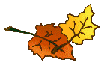
1  Chicken Burger & Veggies | 2  Quiznos Subs | 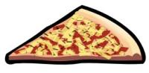  3  Pizza  Picture Re-Take Day | 4  Chicken Poppers & Breadsticks & Carrots  Lunch Orders Due Noon | 5  Garlic Fingers
8  Grill Cheese & Veggies | 9 | 10  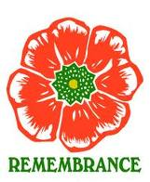  Pizza  Remembrance Day Assembly | 11  (No Classes)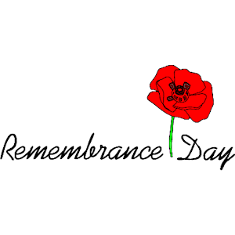 | 12  PEITF Annual Convention / CUPE Annual Convention  (No Classes)
15  PEITF Annual Convention / CUPE Annual Convention  (No Classes) | 16 | 17  Pizza | 18  Chicken Poppers & Breadsticks & Carrots  Lunch Orders Due Noon | 19  Garlic Fingers
22  Chicken Strips & Veggies | 23  Term 1 Report Cards go home | 24  Pizza | 25  Chicken Poppers & Breadsticks & Carrots  Parent Teacher Conferences  (After School) | 26  Parent Teacher Interviews, (K-12)  ( No Classes )
29  Hotdogs & Veggies | 30

