Monday | Tuesday | Wednesday | Thursday | Friday
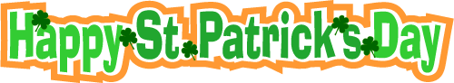

March 2022

28 | 1  Baked Potato | 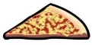  2  Cheese Pizza | 3  Chicken Poppers,  Breadsticks & Carrots  Lunch Order Due at Noon  Parent- Teacher Conference  (After School 2:45-8:00 p.m.) | 4  Parent-Teacher Conference (No Classes)
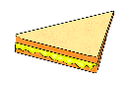  7  Grilled Cheese | 8  Pancakes | 9  Cheese Pizza | 10  Chicken Poppers,  Breadsticks & Carrots  Term 2 Report Cards go Home | 1 1  Garlic Fingers  PA Bingo
14  MARCH BREAK  (NO SCHOOL) | 15  MARCH BREAK  (NO SCHOOL) | 16  MARCH BREAK  (NO SCHOOL) | 17  MARCH BREAK  (NO SCHOOL)  Lunch Order Due at Noon  Happy St. Patrick’s Day | 18  MARCH BREAK  (NO SCHOOL)
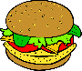  21  Chicken Burger | 22  Baked Potato | 23  Cheese Pizza | 24  Chicken Poppers,  Breadsticks & Carrots  Character Trait Assembly - Honesty | 25  Garlic Fingers
28  Grilled Cheese | 29  Pancakes | 30  Cheese Pizza | 31  Chicken Poppers,  Breadsticks & Carrots | 1 April Fools Day  School Goals Day – No School
Lunch Orders will open on Feb. 26th and will close on March 3rd at noon for lunches the week of March 7th-11th, 2022.
Lunch Orders will open on March 12th and will close on March 17th at noon for lunches the week of March 21st-April 1st, 2022.

