

**St. Jean Elementary School Newsletter**

**December, 2021**



**Principal:** Maureen Cassivi

**Vice-Principal:** Mark J. Kelly

**Administrative Assistant:** Dale MacInnis School Web Page: https://stjeanelementary.wordpress.com/

**Guidance Counselor:** Louise Doucette

**HAPPY HOLIDAYS!**

Wow, it is amazing how quickly the school year can go! It is hard to believe that 2021 is nearing its end and Christmas Holidays are right around the corner. Here we are now in December, with lots of excitement in the air and positive energy filling our school despite Covid. Over the next few weeks, we will continue to cover important school curriculum while at the same time enjoying Holiday cheer! Enjoy a relaxing holiday break! We look forward to moving into the New Year refreshed and ready to embark, explore and embrace all of the new experiences yet to come!

From all of us at St. Jean School, we wish you a very happy and safe holiday season and a Happy New Year!



**Important Dates...**

**December**

**3rd –** H&S Meeting at 1:00 p.m.

**9th –** Holiday Shoppe

**14th –**Virtual Christmas Concert

**15th –** K – 3 Turkey Dinner

**16th –** 4-6 Turkey Dinner

**17th –** Last Day of Classes 2021

**January**

**4th -** 1st Day of School for 2022

Checkout our Facebook Page for School Updates and Information!

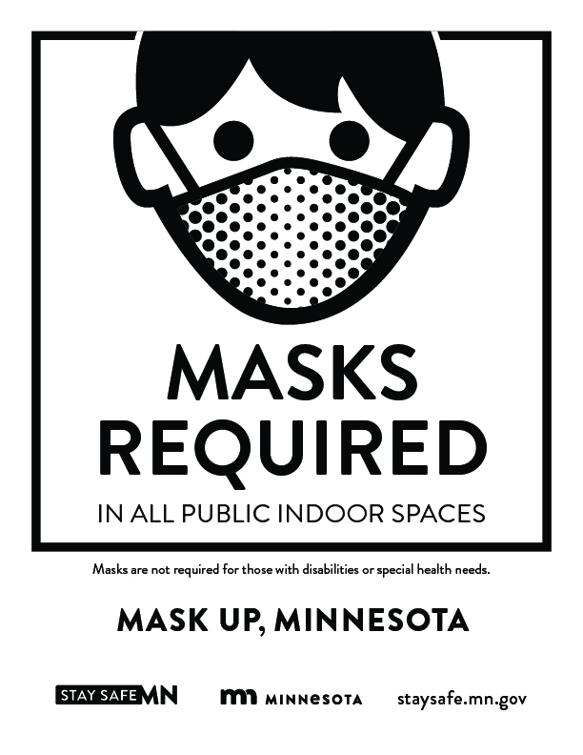



**HOLIDAY SPIRIT WEEK** – **December 13th-17th**

13th Monday – Holiday Hats

14th Tuesday – Wear Red and Green

15th Wednesday – Holiday Sweaters

16th Thursday – Crazy Holiday Hair

17th Friday – Holiday/Favourite Pajamas



**The SJ Holiday Shoppe is a much-loved activity at St. Jean! This holiday**

**event is put on by our grade 5-6 Leadership students. Parents/Guardians are asked to donate new or recycled gifts, and on Thursday, December 9th, the children will “shoppe” for their moms, dads or loved ones, and have the gifts wrapped by SJ School Elves for a Christmas surprise! All donations of wrapping paper, gift bags & tissue paper are also accepted. Gift collection will begin November 16th through Friday, December 14th.**

**Reminder!**

January 4th, 2022 is our first day back to school in the New Year!

***Best wishes to you and your family this holiday season!***



**Our SJ Turkey Dinner will be Wednesday, December 15th for Grade K – 3 and Thursday, December 16th for Grade 4 – 6! A big thanks to Ms. Tracey for planning this Holiday Celebration Dinner for us!**

**Library News from Miss Barb**

**The library has many Christmas and some Hanukkah books for students to read. They will be out on display in December.**

**For Christmas holiday reading, students are reminded that if they have a Public Library borrowing card, the Public Library is open for borrowing. A public library card is free. Parents must go into the library with their child to register for a card.**

**The school library will close for borrowing on Dec. 9th. All students are asked to have returned all library books by Dec.16th. The library will be open for browsing between Dec 9th and Dec. 16th.**

**Home & School Meeting**

**(*December 3rd, 2021 at 1:00 p.m.*)**

**All parents/guardians are invited to attend our meetings. Being involved in your child’s school is important!**

PSB KINDERGARTEN REGISTRATION for 2022-2023 INFORMATION

Reminder to **Parents to please register their children for Kindergarten.**

* Children must be 5 years old by December 31st, 2022 in order to be eligible for Kindergarten.
* Parents are asked to register their child at his/her local elementary school during school hours.  If you are unsure of your school zone, please call the Stratford Office (902-368-6990) or Summerside Office (902-888-8400). Toll Free 1-800-280-7965.
* A registration form will be completed at the time of registration.
* 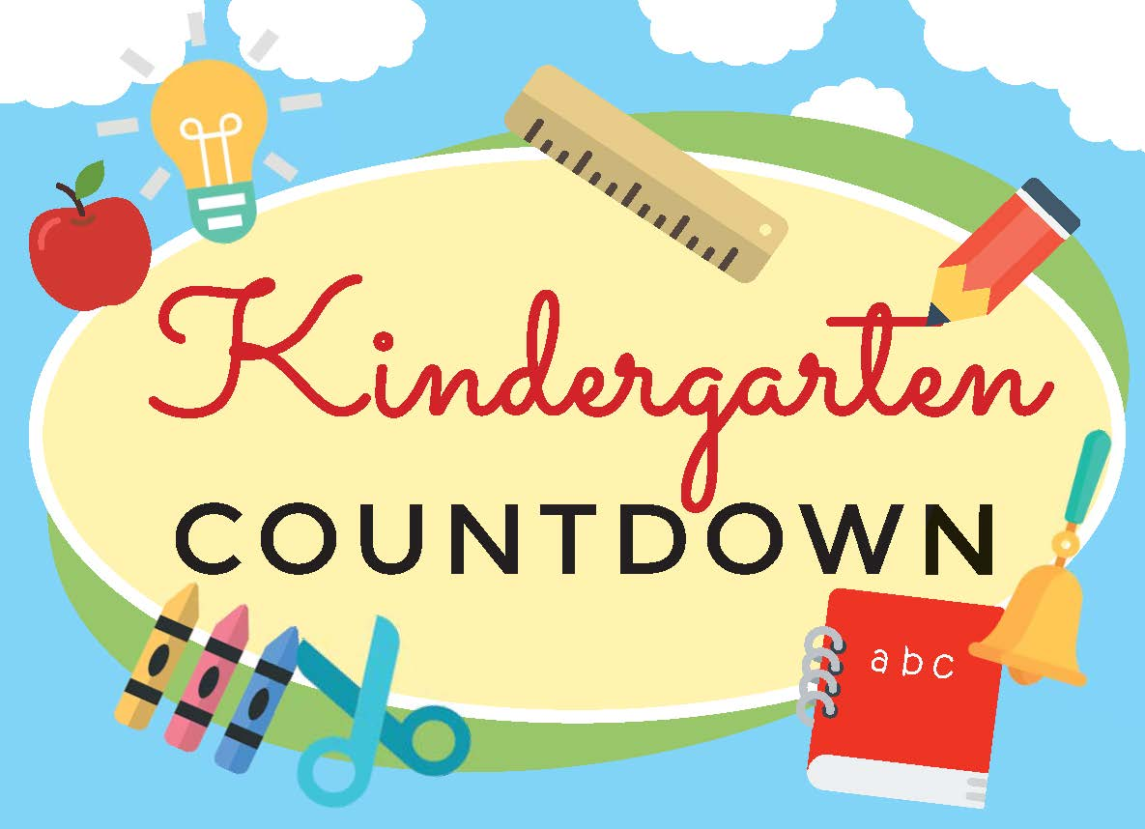Parents are reminded to bring one piece of information which verify proof of child’s age (birth certificate or PEI health card)
* Verification of home address must also be provided, such as current utility bill.
* **Welcome to Kindergarten** sessions for incoming students and their parents will be held in the spring of 2022.





**Outdoor Recess**

**On most days (except on days of inclement weather or when the temperature is below 20 degrees Fahrenheit), students go outside to enjoy the outdoors. If your child is well enough to come to school, they are well enough to go outside during recess. It is very important that students come to school with proper outdoor attire, such as jackets, hats, and gloves, in order for them to be safe and comfortable during recess.**